# The test:

Bettys currently have a one page checkout. We have redesigned this to be vertical.

What should happen (you can see an unstable version of this by adding to your basket and then visiting

https://www.bettys.co.uk/onestepcheckout/?test=789

## When page opens it should look like this:

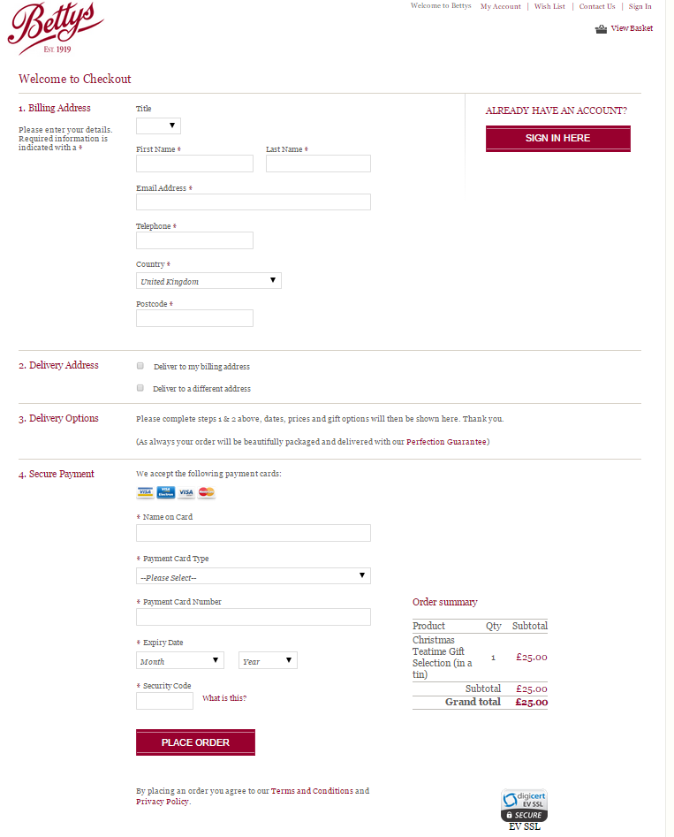

Variations:

* If the order summary gets close to the grey border at the top of Section 4, text in section 3 is compressed to width 400px and the order summary expands upwards. The grey bar also shrinks to 400px width. Similarly the grey bars reduce width if it crosses into section 2 or 1. If it reaches. If it gets close to “Sign in here”, then it should start to further expand downwards, going below the “Place order” button

## When user enters a postcode OR changes their country to be anything other than UK, address section expands

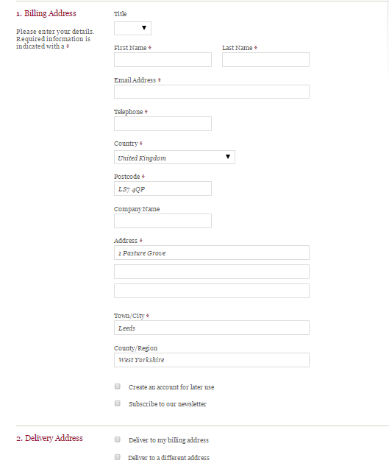

## Section 2

User selects an address by either clicking “Deliver to my billing address”

OR

Clicking deliver to a different address – in which case address section expands

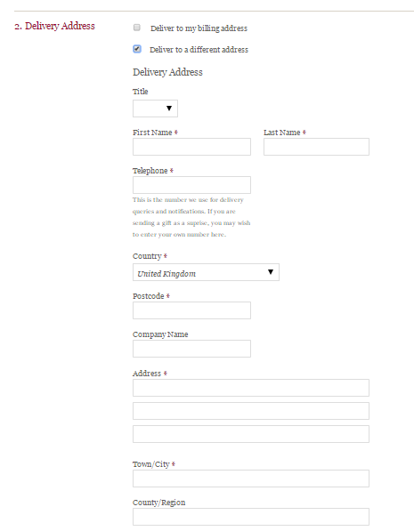

## Section 3

Once the user has either selected delivery to my billing address, or entered their address, delivery information is populated in section 3 and it changes to look like:

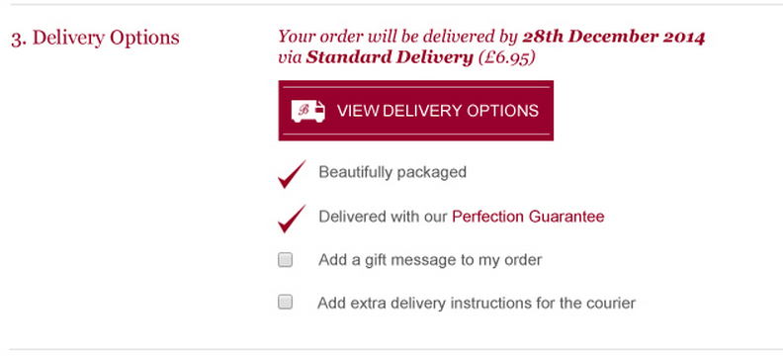

BUT button text should actually read VIEW MORE DATES & OPTIONS

There is also a second variation where instead of the VIEW Delivery Options button there’s a fake drop down menu which also acts as a button:

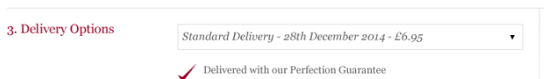

On the existing checkout delivery info is populated here:

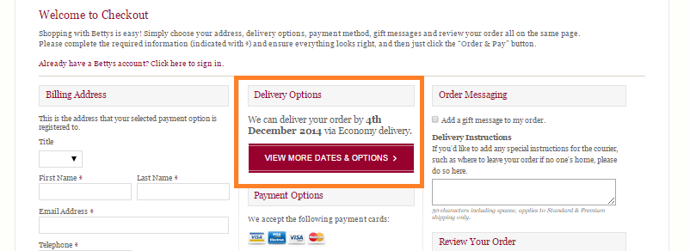

In our test, this info should be used to populate section 3 n.b. confusingly the text “We can deliver etc…” is ordered slightly differently if you change your order It can also be:



I found that I needed slightly different code to extract the key info for each formatting.

Shipping costs are taken from the order summary

*Warning text*

Sometimes delivery isn’t possible, in which case warning text appears instead. This is taken directly from the same section on the existing checkout. There are a couple of different texts, so wording should be copied over

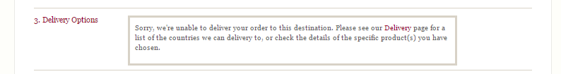

*Perfection Guarantee*

On both the before and expanded versions of Section 3, clicking “Perfection Guarantee” generates a popup

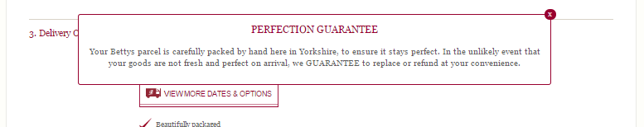

## Section 4 only changes when shipping costs are added to the order summary (this happens at the same time as Section 3 expands)

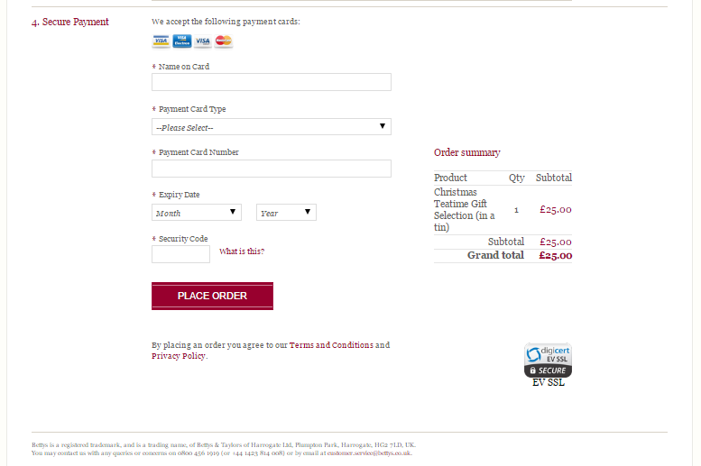

## If the user signs in

The sign in here section disappears

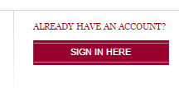

Billing address and delivery address can be replaced by drop down menus where the user selects from their existing addresses or enters a new one

If the user has saved their credit card, then Section 4 can also be compressed (Beware compressing Section 4 means that the Order Summary now reaches section 3 more quickly)

You can create your own account by going to “sign in” at the top left of any page and you can add saved address details etc

## If the user clicks “Place Order” without clicking either checkbox in Section 2

“Deliver to a different address” should become ticked BEFORE the order can be processed. This means that when the address is identified as incomplete, the relevant form fields are highlighted in red and can be seen by the user

## Odd things that have been happening

* On normal form fields, if you click “Enter” the login box is triggered. No idea why this is happening, so I’ve disabled enter on form fields
* When the Sign-in box is completed with a correct username and password, sometimes the refreshing icon on the box continued and nothing happened. To combat this I’ve added a function that listens and if this continues to be the case for a couple of second, then for a couple more, then for a couple more, the whole page refreshes – the user is then signed in
* The Place Order button has stopped working – don’t know why – probably to do with one of the fixes above!
* The text is section 3 has stopped rendering properly (either above the button or in the fake drop down menu - button). Again don’t on why, probably one of the fixes above
* Sometimes the calendar popup (triggered from the button or fake dropdown in section 3) is rendering incorrectly this is from Bettys developers:

*Making multiple amends to order details (going back and amending quantities, changing address details etc) occasionally causes the ATP calendar functionality to fail:*

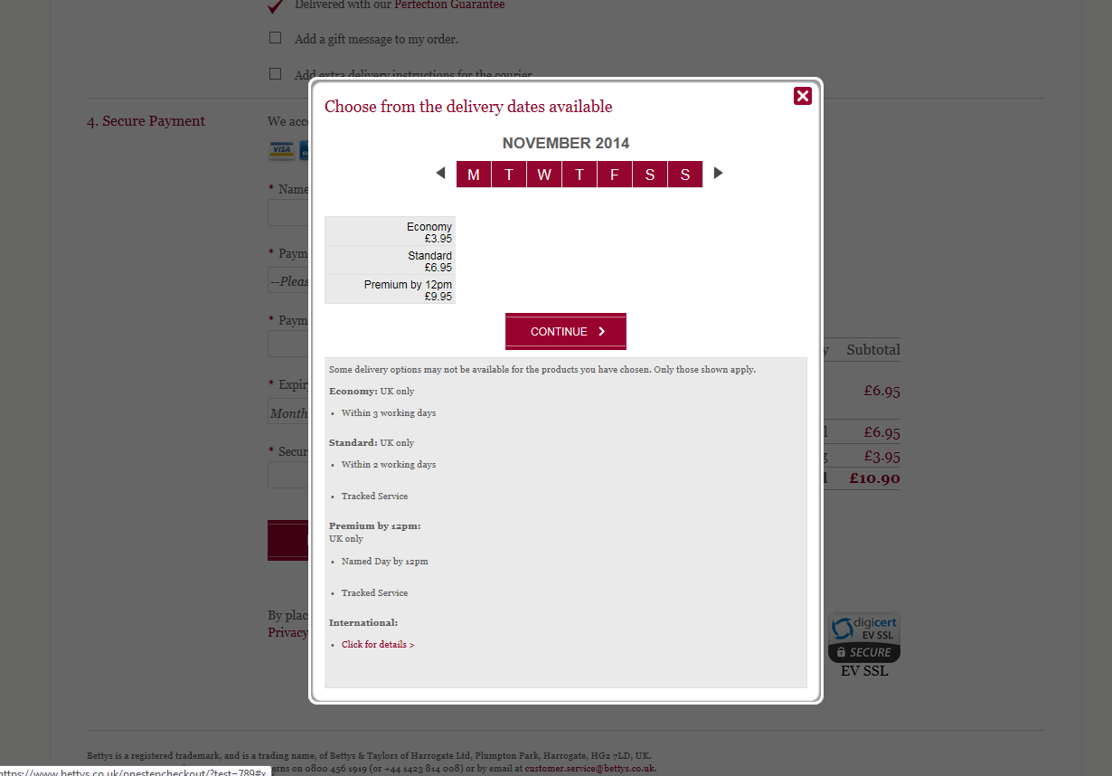  
*In this instance, there was a long pause after clicking on the ‘View More Dates & Options’ button, and then when the ATP calendar popped up, it appeared as above. It was possible to recover from this by toggling the ‘Deliver to my billing address’ off and on again, at which point the calendar began working again, but this has happened a number of times in testing.*

*I’ve asked them to make a video of this happening as I can’t recreate it.*

* After the calendar popup is used to change options, the page automatically moves to the next section, or the earliest incomplete section. We’d like it to stay in the same place, so users can see their updated details in Section 3

## Responsive

The test is responsive for tablets (but won’t be shown to mobiles). My tablets, we just mean iPads and iPad minis. You can see this if you view my version and compress the width

### Browser compatibility

I’ve been testing it on:

Chrome

Firefox

IE 10 & IE 11

I’ve not yet got to safari either on Desktop or iPad.

# My code

Feel free to start again, or build on my very messy code.

I started with ideas of being organised, but gradually lost order as things needed fixed or didn’t quite work as expected!

It’s basically a series of loops listening for key changes and then starting the next loop. I really don’t know what I’m doing at this level so feel free to laugh at it! I’ve quite possibly repeated a few CSS changes trying to find out where to put them to make them work.

# Live and UAT

This currently works in both live (with ?test=789) and on their UAT http://magentouat.bettys.co.uk/ (again with ?test=789)

Please build a new version to add to as Bettys know about “?test=789”

In UAT you can put purchase through – select a credit card type and payment details auto-populate. They recommend you select the same card type each time you test, or UAT can play up.